Week 2 Progress Report – AWS Cloud Learning
Week: 2
Focus
Introduction to the AWS Certified Generative AI Developer – Professional course and learning the fundamentals of Generative AI. Explored the course structure, AWS account preparation, billing awareness, Amazon Bedrock overview, model access, and introductory hands-on activities using the Amazon Bedrock Playground.
Resources Used
• AWS Free Tier Account
• Udemy AWS Certified Generative AI Developer – Professional Course
• AWS Documentation and Tutorials
• Amazon Bedrock Learning Resources
• Practice Exercises and Guided Tutorials
Hands-on Labs Completed
• Optimized the learning environment for completing the Udemy course.
• Reviewed the complete course overview and certification structure.
• Gathered course materials and learning resources.
• Reviewed AWS account signup and billing awareness information.
• Learned the importance of configuring AWS Billing Alarms.
• Explored Generative AI fundamentals and introductory concepts.
• Learned about Amazon Bedrock and its role in AWS Generative AI services.
• Reviewed model access requirements in Amazon Bedrock.
• Started the Amazon Bedrock Playground hands-on lab.
• Continued AWS Generative AI Developer – Professional course lessons and practical exercises.
Topics Covered from Udemy
• Optimizing Your Learning Environment with Udemy
• Course Overview
• Get the Course Materials
• Heads up! Choose the Correct Signup Experience in AWS
• Setting Up an AWS Billing Alarm
• Section Introduction
• Amazon Bedrock Overview
• A Quick Note on Model Access
• Hands-On with the Bedrock Playground
Learning Outcomes
During Week 2, I began my preparation for the AWS Certified Generative AI Developer – Professional certification. I gained an understanding of the course structure, learning materials, and the major topics covered throughout the certification preparation.
I also reviewed important AWS account setup concepts, including selecting the appropriate AWS signup experience and configuring billing alarms to monitor AWS usage and costs.
Additionally, I started learning the fundamentals of Generative AI and explored Amazon Bedrock, which provides access to foundation models and Generative AI capabilities through AWS. I also learned about model access requirements and began exploring the Amazon Bedrock Playground for hands-on interaction with Generative AI models.
These introductory lessons provided a strong foundation for continuing the course and developing practical skills in Generative AI using AWS services. The hands-on activities and guided Udemy tutorials improved my understanding of Amazon Bedrock and its role in building Generative AI applications.
Evidence Collected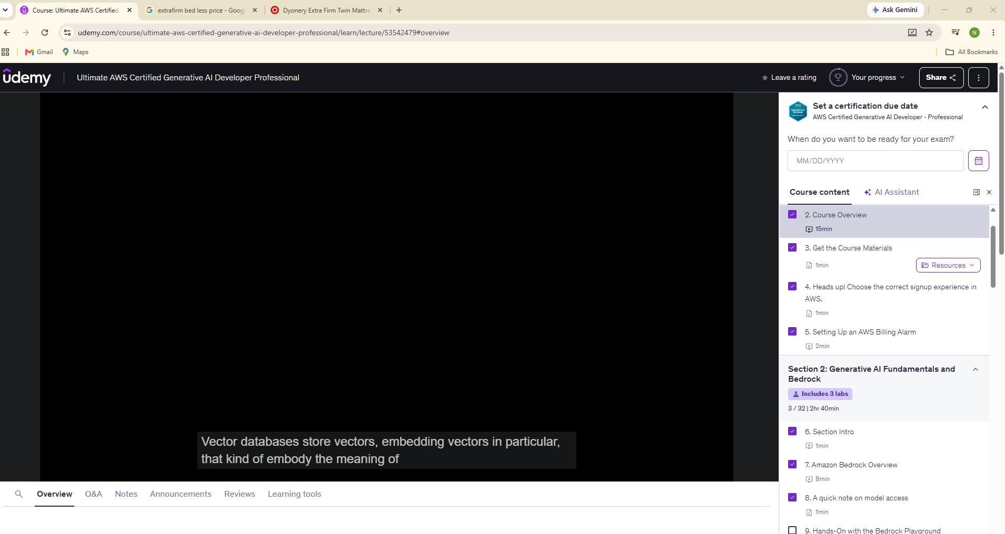

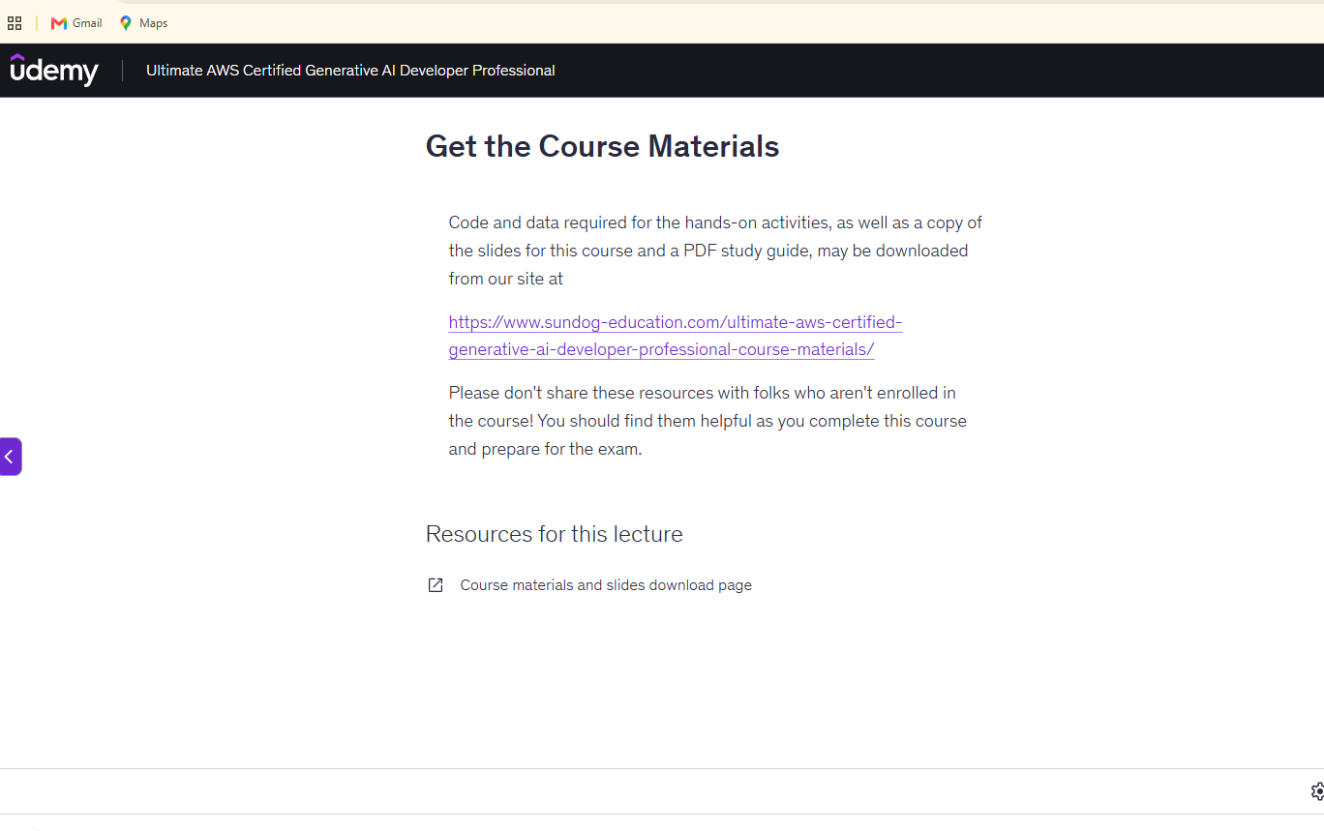
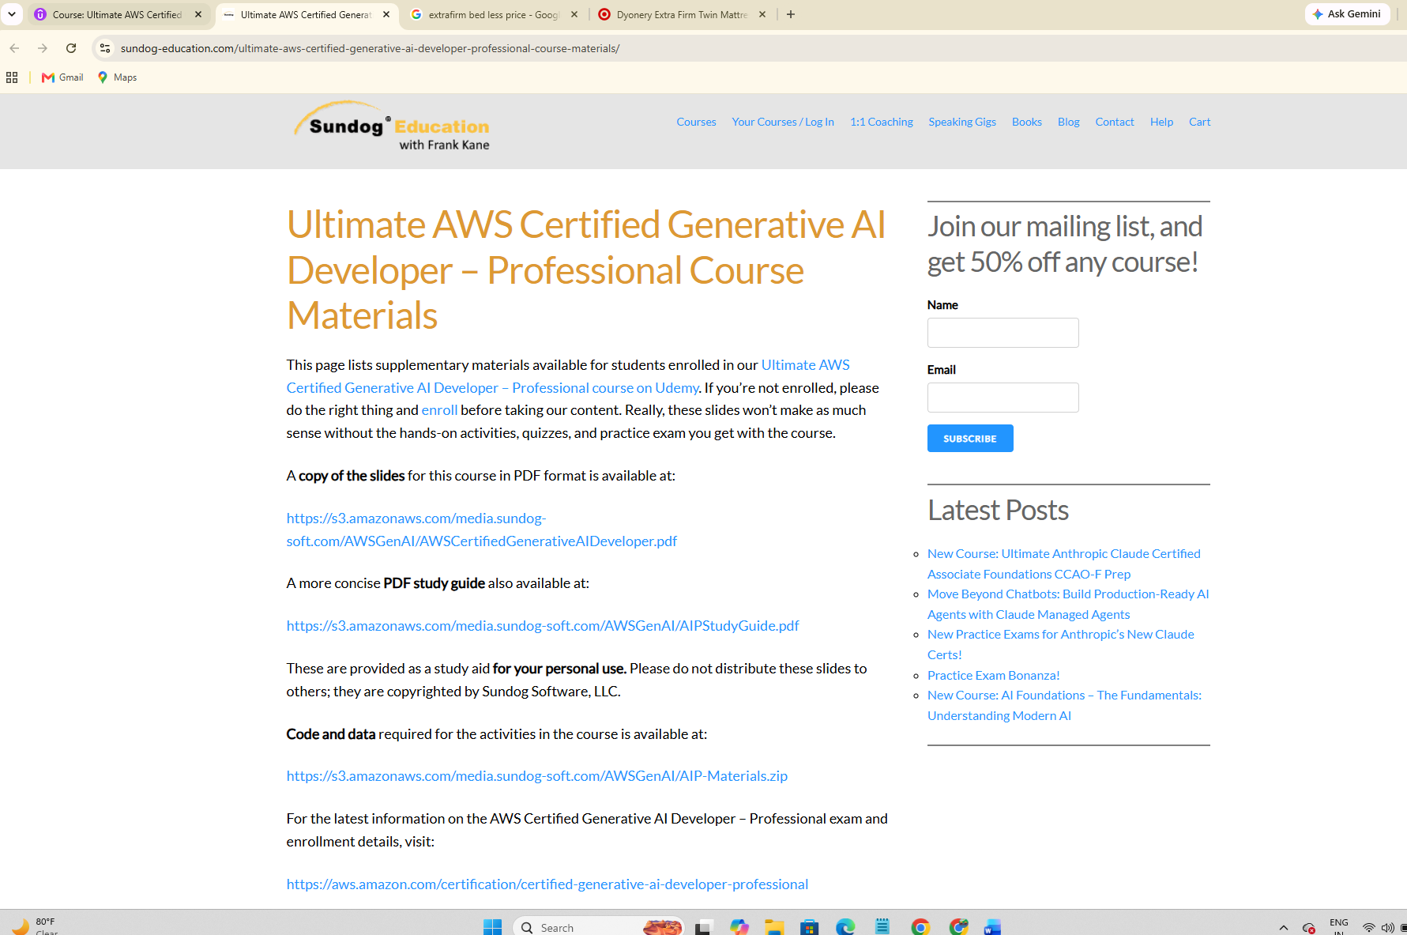

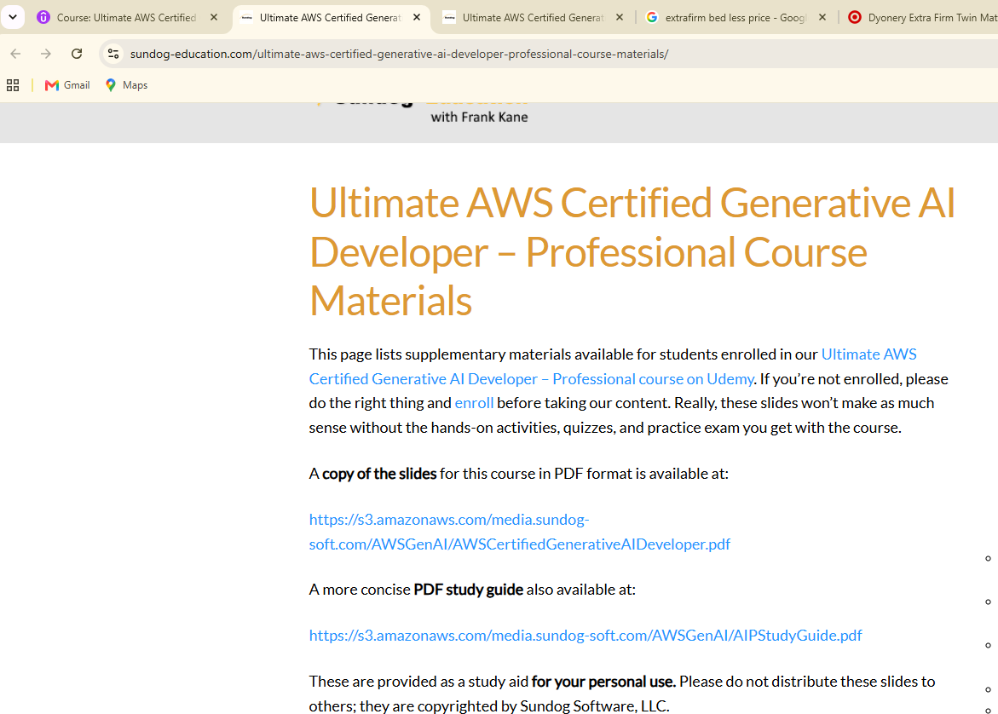

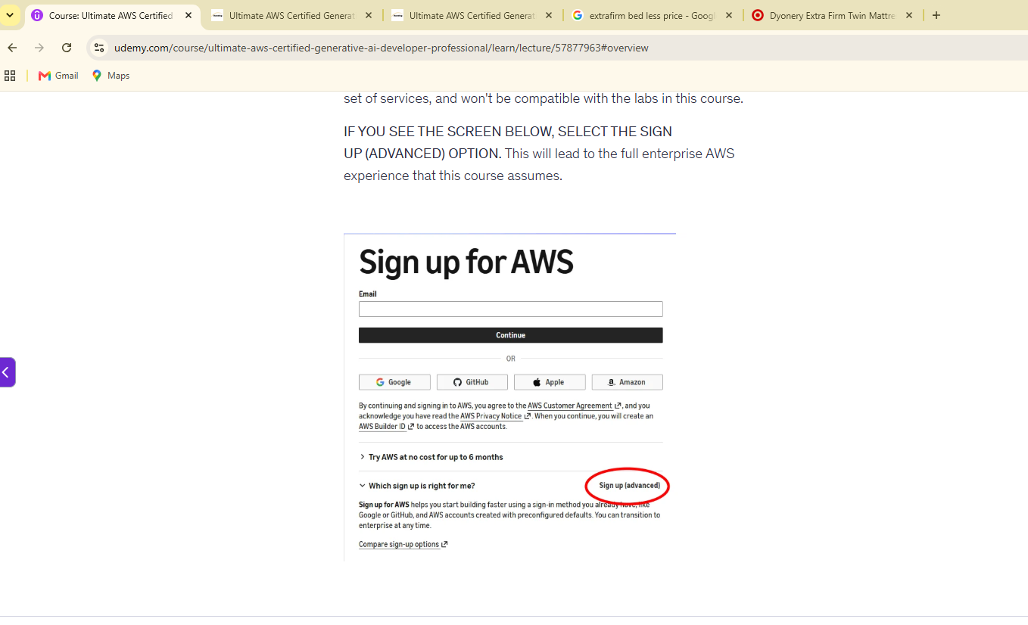


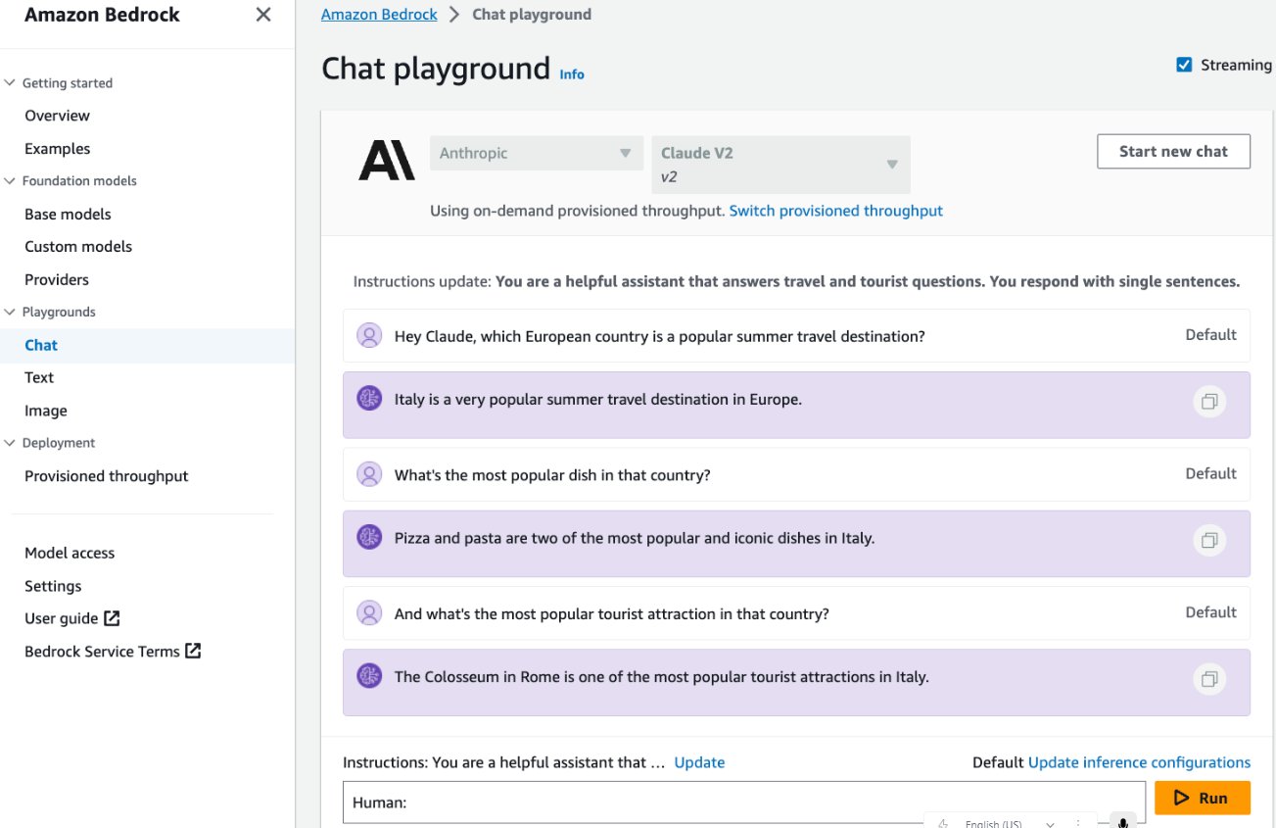

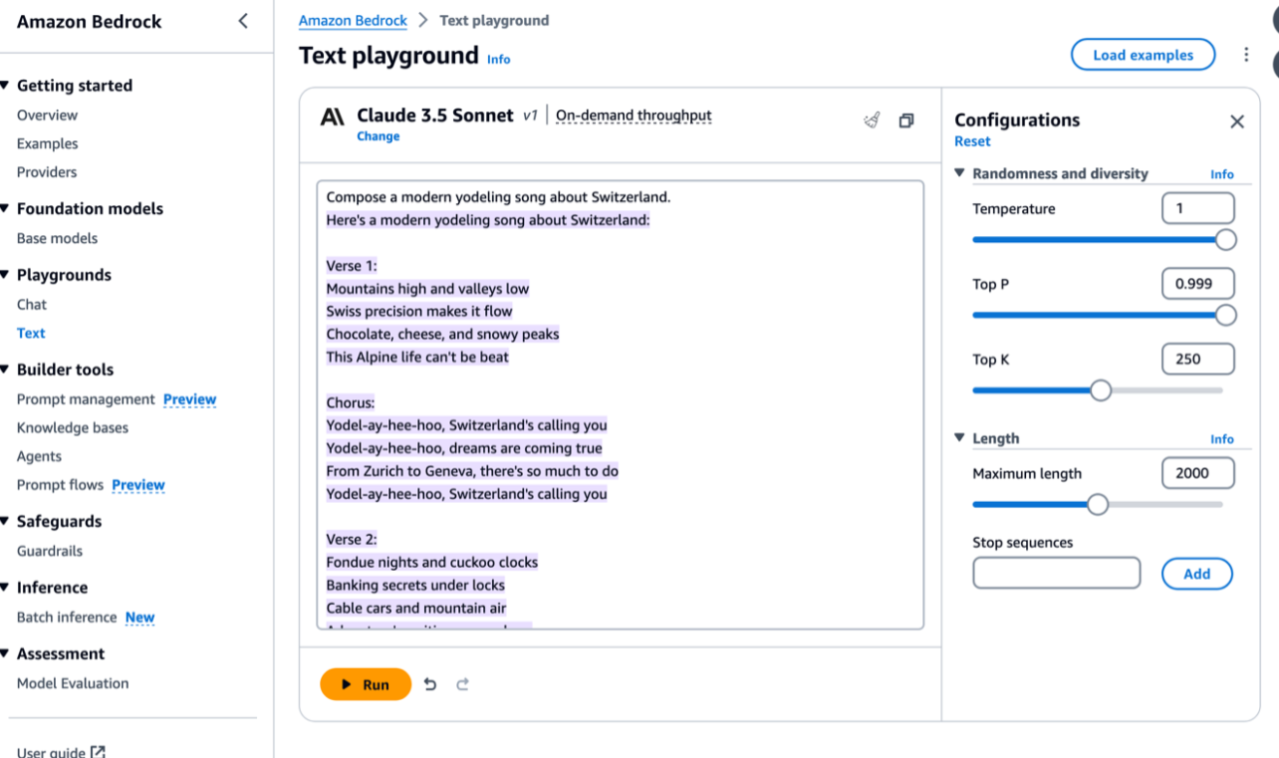
Generative AI and Amazon Bedrock Practical Activities
Tasks Performed
• Reviewed the AWS Certified Generative AI Developer – Professional course structure.
• Organized course materials and learning resources.
• Learned AWS account setup and billing monitoring concepts.
• Reviewed AWS Billing Alarm configuration.
• Explored Generative AI fundamentals.
• Learned the purpose and capabilities of Amazon Bedrock.
• Reviewed Foundation Model access concepts.
• Explored the Amazon Bedrock Playground environment.
• Started hands-on learning activities with Amazon Bedrock.
Issues Faced & Fixes
Issue 1:
Understanding the new AWS Certified Generative AI Developer – Professional certification structure.
Fix:
Reviewed the course overview and learning materials to understand the major Generative AI topics covered throughout the certification course.
Issue 2:
Understanding Amazon Bedrock and Foundation Model access.
Fix:
Reviewed the introductory Amazon Bedrock lessons and course demonstrations to understand how model access works within the AWS environment.
Issue 3:
Understanding AWS billing and account setup requirements.
Fix:
Followed the guided course instructions and reviewed AWS billing alarm concepts to understand how to monitor AWS service usage and avoid unexpected costs.
Next Week Plan
• Continue learning Amazon Bedrock services and capabilities.
• Practice using Foundation Models through Amazon Bedrock.
• Explore prompt engineering concepts.
• Learn about different Generative AI use cases.
• Complete additional Amazon Bedrock hands-on labs.
• Continue progressing through the AWS Certified Generative AI Developer – Professional course.

